System Testing : 01

Guest House Management System

# Check in

|  |  |  |  |
| --- | --- | --- | --- |
| NO | Description | Priority | Responsible |
| 1 | must be auto focus on Room No. before check in | Urgent |  |
| 2 | combo must be editable and filter room no | Urgent |  |
| 3 | set key enter for function check in as button continues check in too | Urgent |  |
| 4 | for item detail not yet work | Urgent |  |
| 5 | form not yet responsive on form for small screen see image below: **001** | Normal |  |
| 6 | Not see total Amount | Urgent |  |
| 7 | Column in grid should have:   * No * Room no/room type (this field include room no and room type. Ex. No.202, VIP) * Customer Name * Check in Date * Phone * Check out date * Status | Normal |  |

**Image:** **001**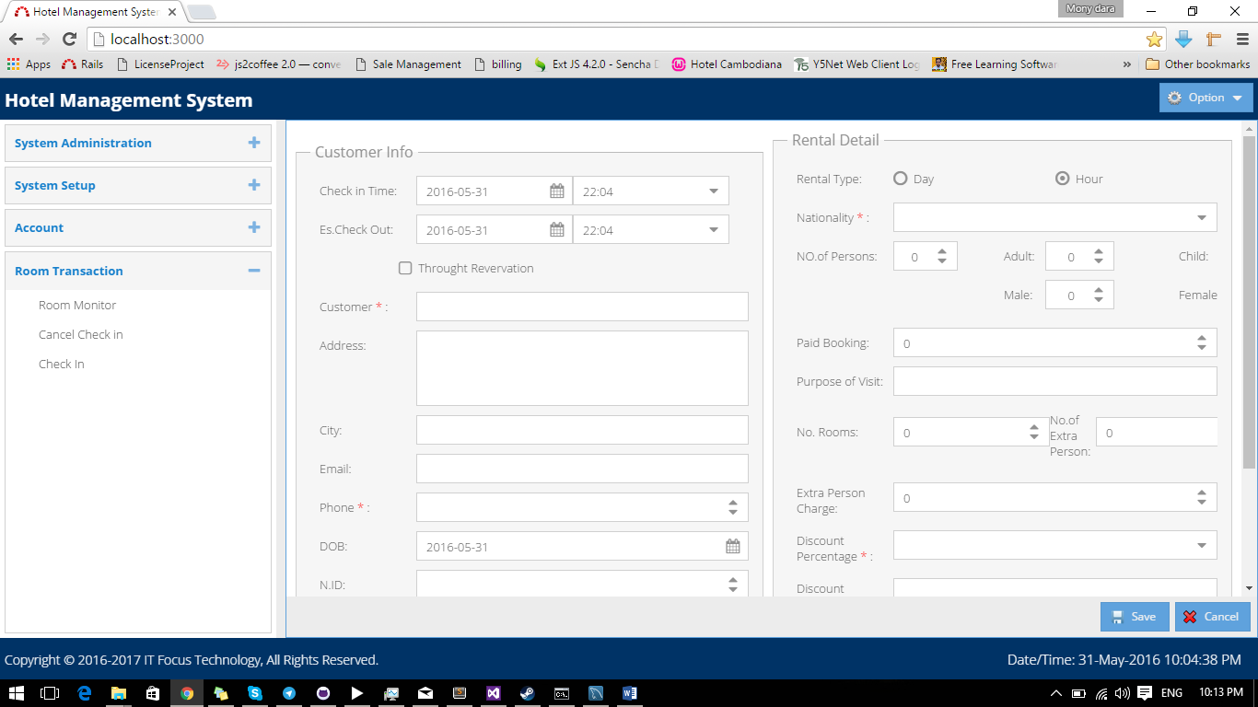

# Room Monitor

|  |  |  |  |
| --- | --- | --- | --- |
| NO | Description | Priority | Responsible |
| 1 | Room Monitor I can’t get view. Check error below: **002** | Urgent |  |

**Image: 002**